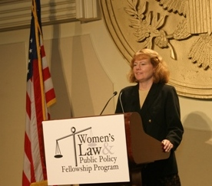
Mary Hartnett has been at Georgetown Law since 1998, first as Executive Director of the Women’s Law and Public Policy Fellowship Program (WLPPFP) and the Leadership and Advocacy for Women in Africa Program (LAWA), and now as an Adjunct Professor of Law and Advisory Board Member of WLPPFP and LAWA. Professor Hartnett is Vice-Chair of the American Bar Association’s Committee on the Rights of Women, and is currently writing, with co-author Wendy Williams, an authorized biography of U.S. Supreme Court Justice Ruth Bader Ginsburg. Professor Hartnett has also served as a Public Policy Scholar at the Woodrow Wilson International Center in Washington, D.C., as a Visiting Professor at the Riga Graduate School of Law in Latvia, teaching International Women’s Human Rights Law, and as a member of the Edmund Muskie Fellowship legal selection committee.
Prior to her positions at Georgetown, Professor Hartnett was of counsel to the international law firm of Coudert Brothers, advising for nearly a decade on international transactions. Professor Hartnett has been actively involved in women's rights issues throughout her career as an international attorney, including representing low-income clients in federal court through her service on the Civil Pro Bono Panel for the U.S. District Court, D.C., drafting amicus briefs for the Women's Legal Defense Fund, and counseling victims of domestic violence. She has a special interest in international women's rights issues, having lived in Bahrain, Norway, Russia, Ireland, Latvia, Uzbekistan, and now Georgia, and is the 2009 recipient of the American Bar Association’s Rasmussen Award for the Advancement of Women in International Law, and the 2005 recipient of the Grinnell College Alumni Award.
Professor Hartnett attended New York University School of Law for her first year of law school as a Root-Tilden scholar, and graduated from Georgetown University Law Center magna cum laude, where she was a member of the American Criminal Law Review and the Sex Discrimination Clinic. She received her undergraduate degree from Grinnell College with honors, where she majored in women's studies and political science, interned and clerked for members of the Iowa House of Representatives and Senate, played varsity softball and captained the women’s tennis team.

